FORMS IN HTML

BY MANSI GUPTA

 Create a registration form page for and sports academy

<!DOCTYPE html>

<html lang="en">

<head>

    <meta charset="UTF-8">

    <meta http-equiv="X-UA-Compatible" content="IE=edge">

    <meta name="viewport" content="width=device-width, initial-scale=1.0">

    <title>Registeration Forms</title>

</head>

<style>

    body{

        background-color: aqua;

    }

</style>

</body >

<img src="https://www.edusys.co/images/sport-academy-management-software.png" height="400"  >

<form align="center">

    <h1> MATHUR SPORTS ACADEMY</h1>

<h3 style="color: rgb(6, 8, 8);">Registeration Form</h3>

<form action="backened,php">

    <label for="Name">Name</label>

        <input type="Name" name="myname" id="Name">

    <br>

    <br>

    <label for="Address">Address</label>

        <input type="Address" name="myadd" id="add">

    <br>

    <br>

    <label for="State">State</label>

        <input type="State" name="mystat" id="stat">

    <br>

    <br>

    <label for="City">City</label>

        <input type="City" name="mycit" id="cit">

    <br>

    <br>

    <label for="Pincode">Pincode</label>

        <input type="number" name="mypin" id="pin">

    <br>

    <br>

    <label for="Date">Date of Birth</label>

        <input type="Date" name="Dated" id="Date">

    <br>

    <br>

    <label for="email">Email</label>

        <input type="email" name="email" id="email">

    <br>

    <br>

    <label for="Date">Date of Joining</label>

        <input type="Date" name="Date" id="Date">

    <br>

    <br>

     Gender: Male <input type="radio" name="Male" checked id="Gender">  Female <input type="radio" name="Female" id="Gender">

     Other <input type="radio" name="Other" id="Gender">

    <br>

    <br>

    <p><label>Name of School/College:<input type="Name" name="my" id="b" ></label></p>

    <br>

    Handicapped: Yes <input type="checkbox" name="check" checked id="Handicapped">No <input type="checkbox" name="checkme"  id="Handicapped">

    <br>

    <br>

    <label for="Are you eligibile?">Are you eligibile?</label>

        <input type="checkbox" name= "eligiblility" id="Are u eligible?">

    <br>

    <br>

    <label for="Write about yourself">Write about yourself</label>

    <br>

        <textarea name="mytext" id="Write about yourself" cols="35" rows="10"></textarea>

    <br>

    <br>

        <input type="image" src="https://st2.depositphotos.com/1853861/7026/v/950/depositphotos_70266117-stock-illustration-submit-button-icon.jpg" height="70" width="60" alt="Sumbit Now">

        <input type="image" src="https://miro.medium.com/max/620/1*A9NgxWTG6tdJolIYoQBz0A.png" height="70" width="60" value="Reset Now">

</form>

</form>

<body>

</html>

OUTPUT:-

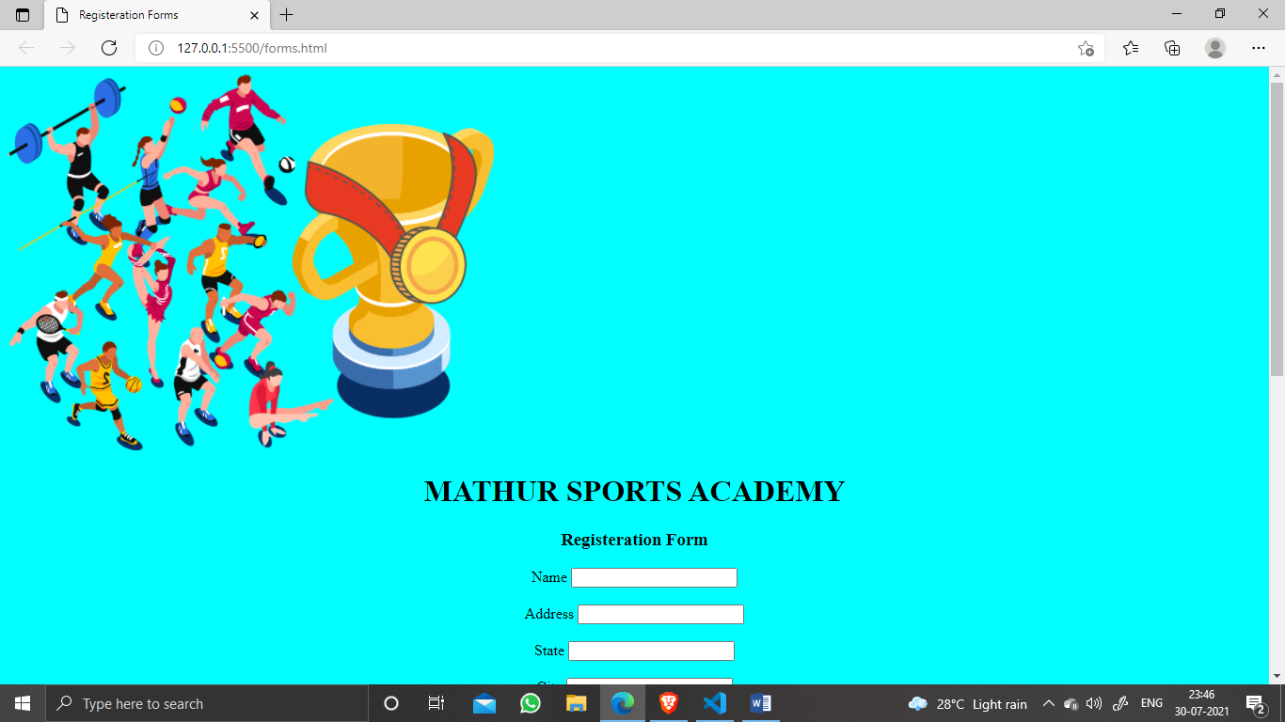

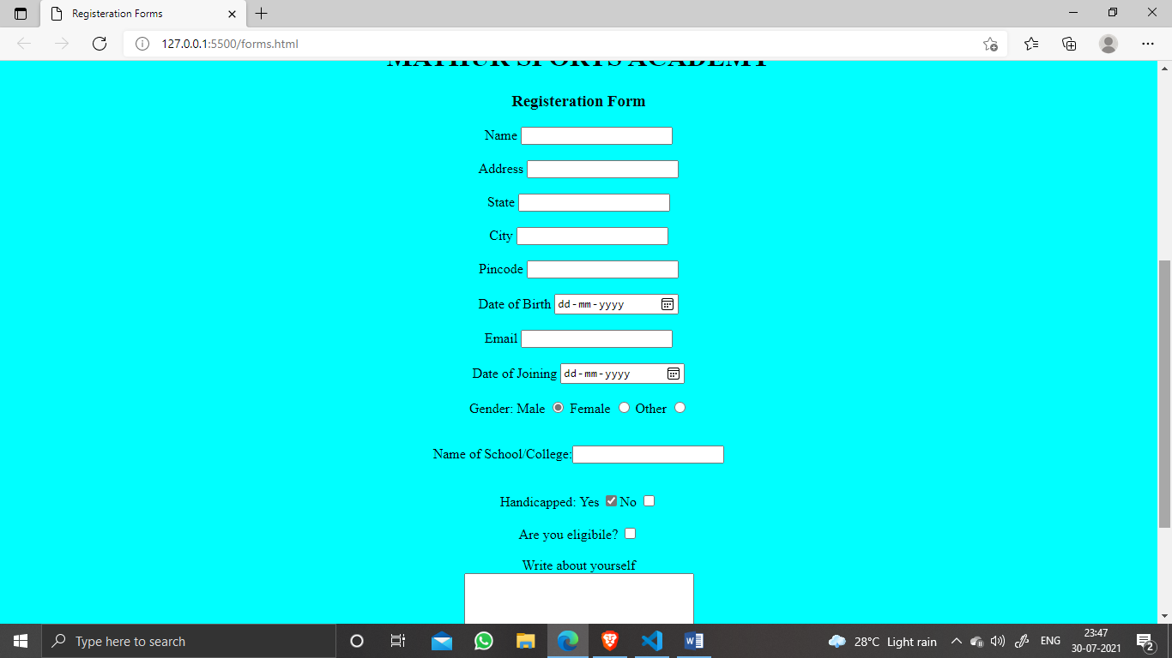

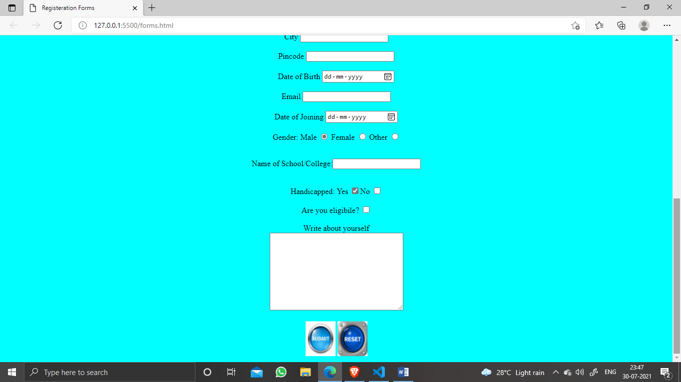

Create a form page for pizza order

<!DOCTYPE html>

<html lang="en">

<head>

    <meta charset="UTF-8">

    <meta http-equiv="X-UA-Compatible" content="IE=edge">

    <meta name="viewport" content="width=device-width, initial-scale=1.0">

    <title>Online food delivery</title>

</head>

<style>

    body{

        background-color: rgb(226, 205, 205);

    }

</style>

<body>

    <form align="center">

        <img src="https://www.india.com/wp-content/uploads/2016/12/5-22.jpg" height="400" width="600">

    <h1 style="color: rgb(97, 65, 18);">PIZZA CORNER</h1>

    <hr>

    <h3>PIZZA ORDER FORM</h3>

    <br>

        <label for="Name">Customer's Name</label>

        <input type=" Name" name="myname" id="Customer's Name">

        <br>

        <br>

        <label for="Mobile">Contact no.</label>

        <input type="number" name="Myno" id="Contact no.">

        <br>

        <br>

        <label for="Email">Email id</label>

        <input type="email" name="myemail" id="Email id">

        <br>

        <br>

        <fieldset width="500">

        <legend style="color:blue"><h2> Pizza Size</h2> </legend>

        <p><label> <input type="radio" name=size  id="d" style="color:blue" value="small"> Small </label></p>

        <p><label ><input type="radio" name="size" id="e" value="Medium">Medium</label></p>

        <p><label ><input type="radio" name="size" id="f" value="Large">Large</label></p>

        </fieldset>

        <br>

        <fieldset width="500">

            <legend style="color:blue"> <h2>Pizza Toppings</h2> </legend>

            <p><label> <input type="checkbox" name="a" id="g" value="Bacon"> Bacon </label></p>

            <p><label> <input type="checkbox" name="b" id="h" value="Extra Cheese"> Extra Cheese </label></p>

            <p><label> <input type="checkbox" name="c" id="i" value="Onion"> Onion </label></p>

            <p><label> <input type="checkbox" name="d" id="j" value="Mushroom"> Mushroom </label></p>

           </fieldset>

           <p><label>Preferred delivery time: <input type="time" min="11:00" max="21:00" step="60"></label></p>

           <p><label>Address: <input type="Address" maxlength="8"></label></p>

           <p><label>Delivery instructions:<textarea maxlength=10></textarea></label></p>

           <p><label>No. Of Pieces :<input type="number" id="k"/></p>

           <p id="or"><input  type="button"  value="Process order"/>

           <input  type="Reset" id="cl" value="Cancel"></p>

    </form>

</body>

</html>

OUTPUT:-

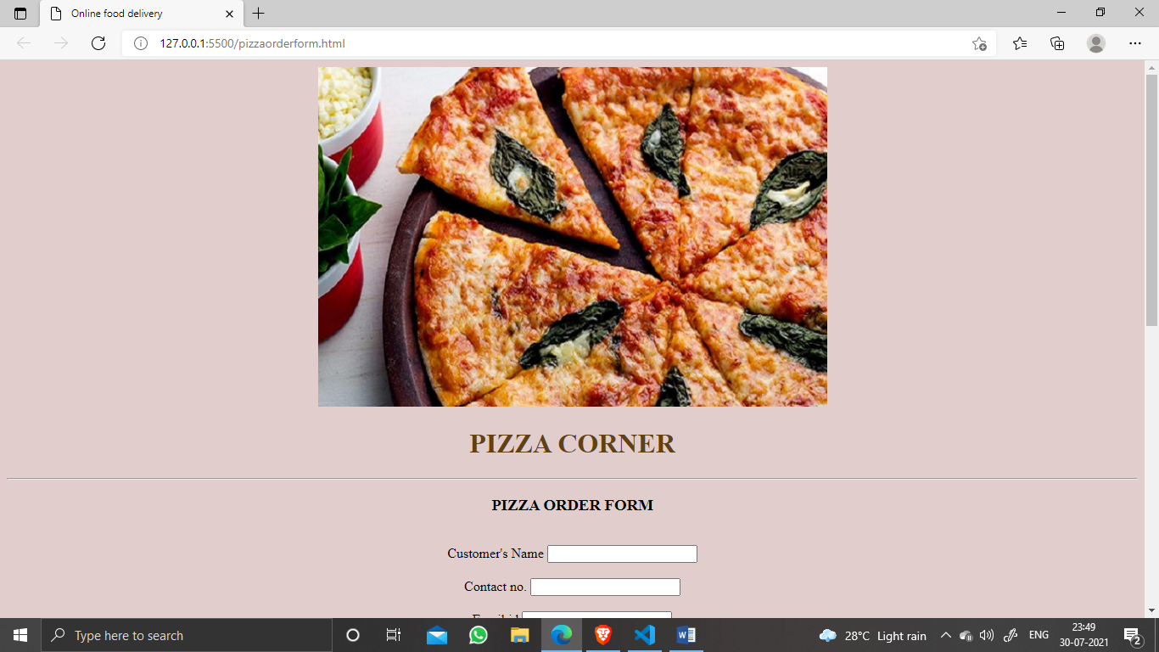

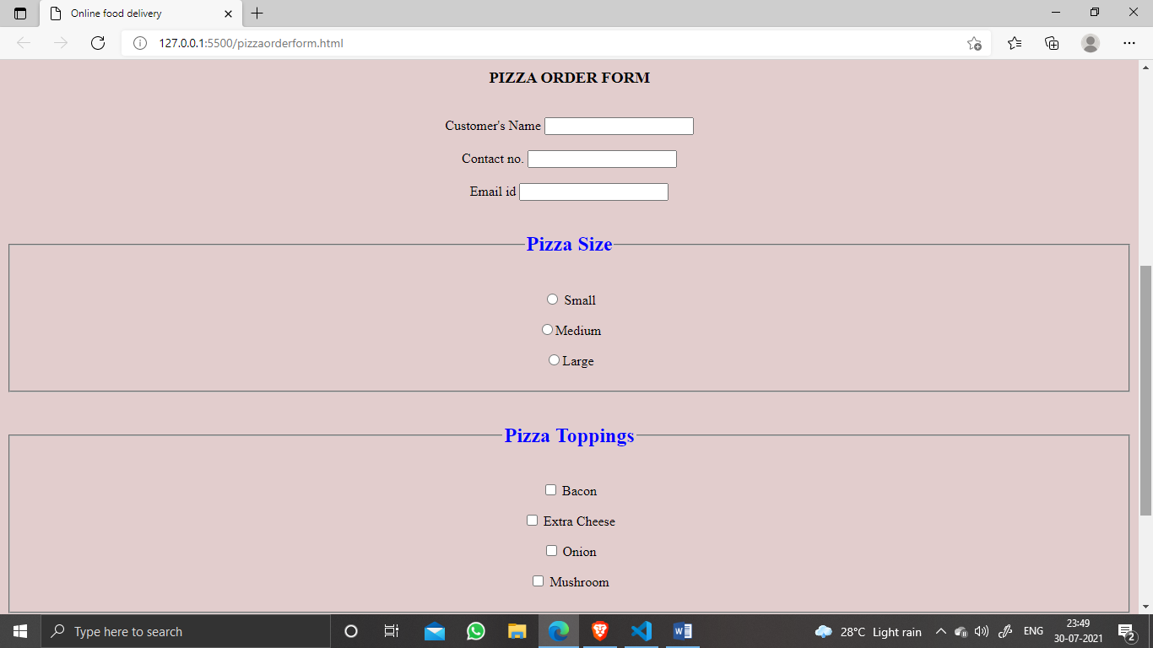

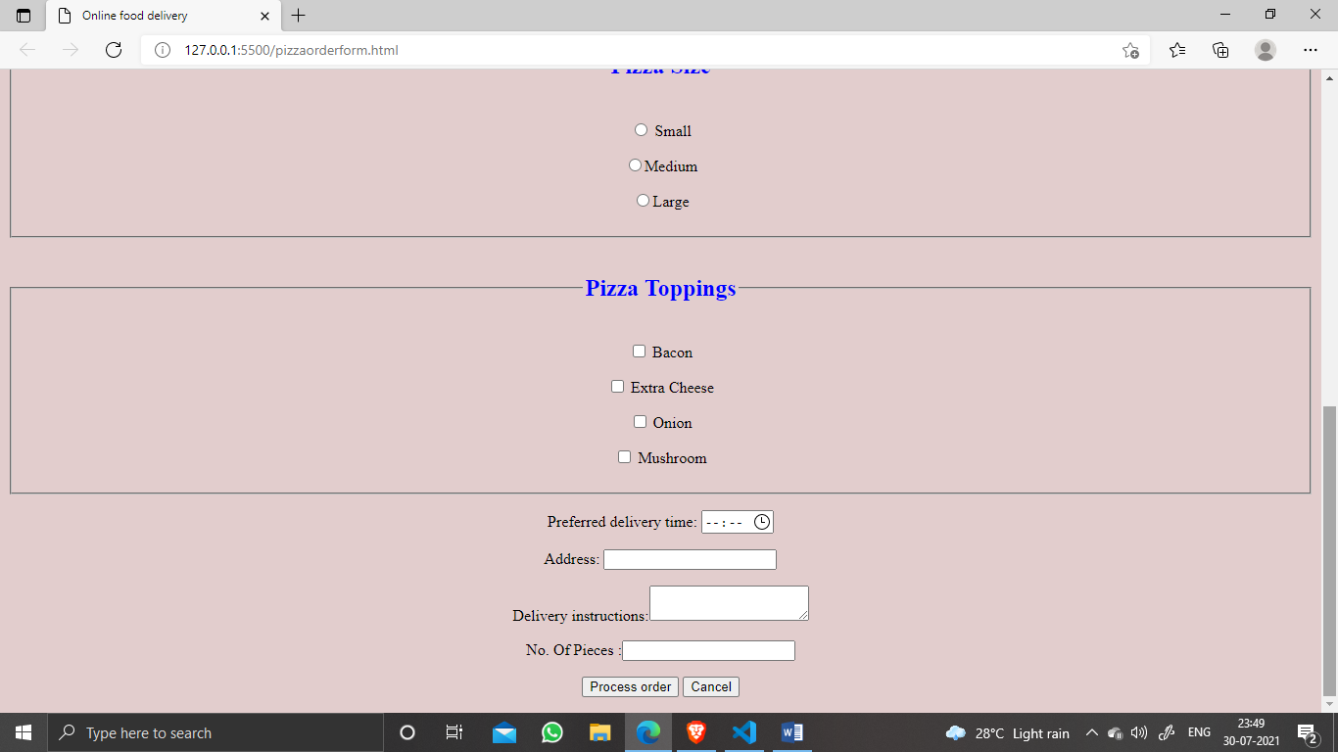

 Create a login form for the sports academy

<!DOCTYPE html>

<html lang="en">

<head>

    <meta charset="UTF-8">

    <meta http-equiv="X-UA-Compatible" content="IE=edge">

    <meta name="viewport" content="width=device-width, initial-scale=1.0">

    <title>Login page</title>

</head>

<body>

    <form align="center">

        <img src="https://yt3.ggpht.com/ytc/AKedOLTVnnJLWcgXtvjY-ymLlGd58_ujJpD0DcGvyjXphg=s900-c-k-c0x00ffffff-no-rj" width="300" height="300" >

        <fieldset width="500" height="500">

        <h3>LOGIN</h3>

        <p><label><strong>Username</strong> <input type="nameu" id="my" name="u" required></label></p>

        <p><label><strong>Password</strong> <input type="password" id="myry" name="us" required></label></p>

        <button type="submit">Login</button>

        <span class="psw">Forgot <a href="#">password?</a></span>

        </fieldset>

    </form>

</body>

</html>

OUTPUT:-

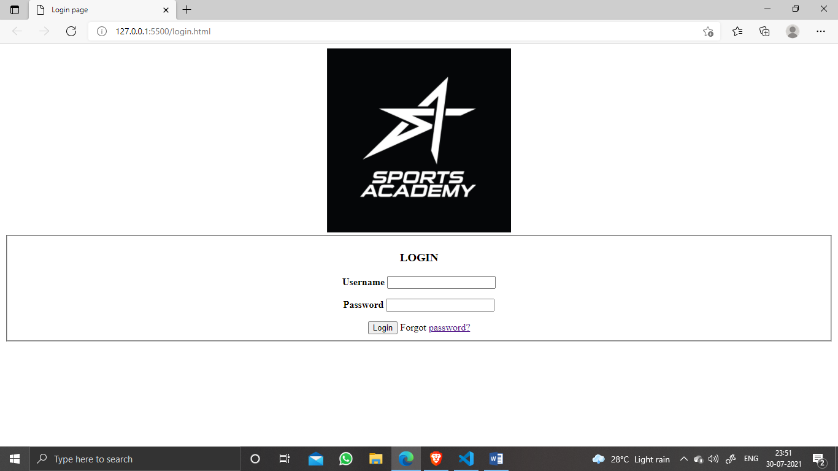

Create a form for booking ticket which include  date , Name ,Email ,Person , Ticket type in its field

<!DOCTYPE html>

<html lang="en">

<head>

    <meta charset="UTF-8">

    <meta http-equiv="X-UA-Compatible" content="IE=edge">

    <meta name="viewport" content="width=device-width, initial-scale=1.0">

    <title>BOOK TICKET</title>

</head>

<style>

    body{

        background-color: antiquewhite;

    }

</style>

<body>

    <img src="https://media.nomadicmatt.com/bookaflight.jpg" height="200" width="1500">

    <p>Contact Us:9908567890</p> <p>email:guiuh@bjsdan.com</p>

    <form align="center">

        <h1>BOOK TICKET FOR FLIGHT</h1>

        <fieldset>

        <label for="Name">Name</label>

        <input type="Name" name="myname" id="Name">

    <br>

    <br>

    <label for="State">State</label>

        <input type="State" name="mystat" id="stat">

    <br>

    <br>

    <label for="City">City</label>

        <input type="City" name="mycit" id="cit">

    <br>

    <br>

    <label for="Pincode">Pincode</label>

        <input type="number" name="mypin" id="pin">

    <br>

    <br>

    <label for="email">Email</label>

        <input type="email" name="email" id="email">

    <br>

    <h3>Age:</h3>

    Adults:12+years <input type="radio" name="ll" id="op">

    <br>

    Child:(2-11years) <input type="radio" name="pl" id="op">

    <br>

    Infants:(0-2years) <input type="radio" name="il" id="op">

    <br>

    <br>

    <label for="Date">Departing</label>

        <input type="Date" name="Date" id="check-in-Date">

    <label for="Date">Returning</label>

        <input type="Date" name="Dat" id="chec-out-Date">

    <br>

    <br>

    <label for="Leave">Leaving from</label>

        <input type="Leave" name="hh" id="le">

    <label for="return">Going to</label>

        <input type="return" name="jj" id="le">

        <br>

        <br>

    <strong>Type of Flight:</strong><br> Economy Class Flight <input type="checkbox" name="yy" checked id="hee">

    <br>

    Premium Economy Class Flight <input type="checkbox" name="xy"  id="hee">

    <br>

    Bussiness Class Flight <input type="checkbox" name="py"  id="hee">

    <br>

    First Class Flight <input type="checkbox" name="uy" id="hee">

     <br>

    <button><img src="http://www.melbournebrewerytours.com.au/wp-content/uploads/2020/02/Book-Now-Button-Transparent-PNG.png" width="80"></button>

    </fieldset>

    </form>

</body>

</html>

OUTPUT:-

